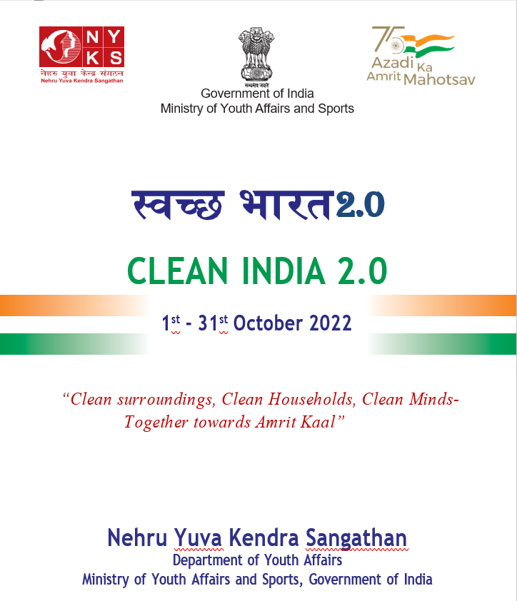

Background

“The Panch Pran of Amrit Kaal- Goal of developed India, to remove any trace of colonial mindset, take pride in our roots, unity and sense of duty among citizens….”
Sh, Narendra Modi
Hon’ble Prime Minister
15th August, 2022

Taking forward the Prime Minister’s message of 5 resolves (Panch Pran) for Amrit Kaal and in continuation of the celebration of Azadi Ka Amrit Mahotsav, Nehru Yuva Kendra Sangathan (NYKS) Deptt. of Youth Affairs, Ministry of Youth Affairs and Sports is undertaking “Clean India 2.0”.
The program aims to prepare the citizen of India for Amrit Kaal not just by cleaning their houses and surroundings but also by cleansing their minds of all the hatred, doubts and other negative thoughts.
The program is aimed at swacchta that is both internal and external. Internalization of Swachchta as a value would enable both clean and serene mental and physical environment for citizen during the Amrit Kaal.

Objectives:
- To organize cleaning of public spaces and households across all the districts of the country from 01st October to 31st October 2022.
- To spread the message of Swacch Mann- to get rid of all negative thoughts, jealousy, self-doubt, feeling of helplessness and embrace positivity, hope and confidence for a better future
- To involve all segments of society, Government organizations including PRIs and Non- Government Organizations to instill awareness and feeling of pride among citizens to keep their surroundings clean and waste free.
- To make the program as People’s Movement through Jan Bhagidari.
- To propagate the mantra of “Swachch Kaal : Amrit Kaal”.

Key Activities of the Program:
- Collection & disposal of waste - through collection drives and door to door campaign.
- Village Beautification- Maintenance and beautification drives for historical monuments and heritage sites, Community Centres, Youth Club/Mahila Mandal Buildings, School Buildings, Panchyat Buildings etc.
- Traditional Water Sources- Cleanliness and maintenance through Shramdaan (Voluntary Work Camps), De-silting and Cleaning of Water Bodies.
- Heritage Maintenance- Maintenance and beautification drives for historical monuments and heritage sites, Freedom fighters memorials, places associated with unsung heroes etc.

Three Phases of the Campaign
- Preparatory Phase
- Launching Phase
- Collection of Waste and Disposal and concluding event.

Outcome:
- Collection & disposal of 1.11 crore kg waste (plastic, e-waste and other waste) throughout the Country covering all districts and 6 Lakh Villages.
- Hotspots for Waste Collection: Tourist Places, Educational
- Institutes, Bus Stand/Railway Stations and the vicinity, National Highways, Historical and heritage buildings, religious places & surroundings, Hospitals and Water Resource

Collaboration with:
- State Governments
- District Administration, Municipalities and PRIs
- Educational Institutes, Religious Bodies, Professional groups, Civil Societies & Community Based Organisations
- National Sports Federations, IOA and other Sports Bodies
- Religious bodies i.e. Art of Living, Patanjali Yoga Peeth, Isha Foundation, Radha Swami Satsang, Brahmkumaris, Isckon etc.
- UNICEF and other UN Agencies for resource mobilization
- NSS, BS&Gs and HS&Gs

Preparatory Phase
Time Line- 28th^{th} September to 30th September 2022
- Formation of State and District Level Committees under the Chairmanship of Chief Secretaries and DM/DC respectively.
- Formulation of Action Plan and sharing with all stakeholders i.e. District Administration, DRDA, Local Municipal Corporations, PRIs, NSS and BS&G, HS&Gs, Youth Clubs, Mahila Mandals, SHGs, Community Based Organization (CBOs) such as Rotary Clubs, Lions Clubs, Red Cross etc. working in the Districts and Villages.
- Meeting with Chief Secretaries/Secretary Youth Affairs of all States (by Secretary Youth Affairs, GoI), with Central Pollution Control Board and State Pollution Control Boards.
- Meeting with Secretaries, GoI of Ministry of Urban Development, RD&PRI, Education, Jal Shakti, Environment, Forest and Climate Change, Secretary Banking Sector and Chairman NHAI etc.
- Coordination meeting with all DMs/ZilaPramukhs/CEO ZilaParishad/ Mayors/Pradhans by State Directors and DYOs.
- Hon’ble Minister of Youth Affairs & Sports with Union Minister of UD, RD&PRI, Education, Ministers of Youth Affairs of all States and DM/DC of all Districts.
- Identification of Location for collection and disposal of waste at all levels by village Youth Volunteers, NYVs, District Youth Officers in collaboration with District Authorities including Municipalities and PRIs.
- Design and Distribution of T-Shirts and collecting material (polybag) for collection of waste.

Launching Phase
Time Line- 1st October 2022
- Programme to be launched by Hon’ble Minister of Youth
- Affairs & Sports on 1st October 2022 at Prayagraj.
- Simultaneous functions in all Districts felicitating old persons and cleaning old-age homes in conjunction with International Day for Older Persons.
- Program at Prayagraj (Minimum Participants: 750)
- Skit
- Interactive session with Youth by Hon’ble Minister of Youth
- Affairs and Sports
- Painting by 200 Young Artists
- Signage and Pledge
- Formal Launch by Hon’ble Chief Guest. Program to be held at 05 locations in Prayagraj and Hon’ble Chief Guest will attend all the programs.

Waste Collection & Disposal & concluding event
Time Line- 1st October to 31st October, 2022
Themes Suggested (Indicative Calendar enclosed as Annexure 1):
- Inauguration and Gandhi Jayanti
- Festivals/Traditional Fair Week
- Iconic Week
- Professional Groups/ Trade groups/Institutions
- Swacch Ghar Samridh Ghar
- PSU & Government Warehouses
- Public establishments/Community Spaces
- Valedictory Function
- Both villages based NYKS affiliated Youth Clubs and NSS affiliated Educational Institutions will formulate days wise calendar of activities and locations in line with the indicative schedule placed at Annexure 1.
- Awareness campaign on Swacch Mann – Clean environment for clean mind shall accompany all the cleaning activities where the participants may be urged to focus on the positive and have a hopeful outlook about life.
- Waste Collection in villages through door-to-door Campaign by Village based Youth Clubs/ Mahila Mandals/ SHGs and others
- Similar Waste Collection in town/urban areas by the students of schools and Educational Institutions, NSS, BS&G and HS&G.
- NYKS to coordinate with Professional groups, Religious Bodies, Government and Non-Government Organisations etc. to collect and dispose waste on given specific dates in designated areas. DYOs and NYVs will be the focal point for collaboration.
- Continuous daily drives will be conducted to achieve the targets and weight of waste collected/disposed shall be maintained.
- For all cleaning activities, before and after photos shall be collected and stored as record for publicity with maximum impact.
- A concluding event to be organized on 31st October with felicitation of volunteers and participant departments and clubs in the campaign.

Media/ Social Media Strategy:
- Involvement of Media from Day-1 of preparation.
- Extensive Media coverage during all three phases of the program. Collaboration with Doordarshan, Akashvaani, PIB.
- Optimum use of Social Media Platforms i.e. Twitter,
Facebook, Instagram, YouTube, WhatsApp Groups
- Popularization of Hashtags i.e., #CleanIndia2.0
- Theme based posts to be made.
- Use of Creatives (jingles, memes, e-posters) for the popularization of theme

Monitoring, Supervision and Follow up:
- A central command center at NYKS HQ to coordinate with RDs and SDs for close monitoring of targets the progress of the campaign program.
- Director (prog.), Regional Directors , JD (prog.) and State Directors shall conduct field visits to monitor progress of the campaign in different parts of the country.
- HQ , RD offices and State offices shall ensure that the State as well as the district level committees are formed and coordination is smooth with other departments of state government/district administration.
- Locations identified and partner youth clubs and agencies/departments for the clean India Program 2.0 may be sourced from field offices in a pre event reporting format and the progress of the same may be monitored by the Regional/State offices.

