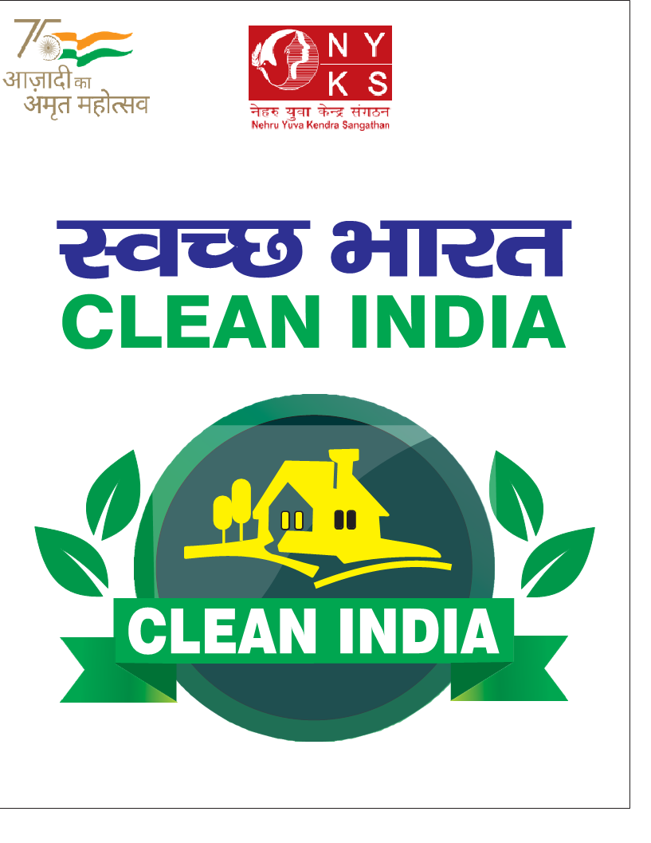

Guidelines for the Implementation of
Clean India Programme

Background:
Country is celebrating Azadi ka Amrut Mahotsav as a part of commemoration of its 75th years of India’s Independence. This is to celebrate and commemorate 75 years of progressive India and its glorious history, people, culture and achievements.

Hon'ble Prime Minister while inaugurating the curtain raiser of Azadi ka Amrut Mahotsav on 12th March 2021, said that “The celebrations can be divided in five sub-heads - Freedom struggle, Ideas at 75, Achievements at 75, Actions at 75, and Resolve at 75.”

Concept:
NYKS,Deptt. Of Youth Affairs have conceptualized celebration of Azadi ka Amrut Mahotsav under the pillar of Actions and Resolves @75 with the overarching Spirit of Jan Bhagidari and Jan Andolan

Clean India Programme has been planned in the background of above context and with a view to mobilize public opinion and ensure involvement of citizen of the country to participate voluntarily in this nationwide drive of waste collection and their disposal.

Swacchta Abhiyan was launched by Hon’ble Prime Minister Sh Narendra Modi ji during 2014 and since then, remarkably headway can be noticed in this regard. The NYKS initiative is continuation of initiative spearheaded by the Hon’ble Prime Minister with renewed focus and commitment.

Clean India is not just a programme but it reflects the genuine concerns of common man and their resolve to address the issue head on. Therefore, ensuring cleanliness in the country in the 75th Years of independence becomes responsibility of all of us as a responsible citizen.

Need:
To celebrate Azadi Ka Amrit Mahotsava, Deptt. of Youth Affairs, Ministry of Youth Affairs and Sports is undertaking “Clean India”Program. The program is aimed at creating awareness, mobilization of people and ensuring their involvement in the Clean India initiative which is unique in terms of scale and participation.

Objective:
- To organize activities to clean waste mainly Single Use Plastic waste throughout the country from 01st October to 31st October 2021.Program will be organized in all 6 lakh villages through NYKS affiliated Youth Clubs & NSS in all 744 Districts of the country.
- To involve all segments of society, Government organizations including PRIs and Non-Government Organizations to instill awareness and feeling of pride among citizens to keep their surroundings clean and waste free.
- To make the programas People’s Movement through Jan Bhagidari.
- To propagate the mantra of “Clean India: Safe India”.

Implementing Agency:
Nehru Yuva Kendra Sangathan, Department of Youth Affairs, Ministry of Youth Affairs & Sports, Govt. of India.

Coordination and Support Agencies:
Respective State Governments and District Administration Departments viz. Urban Development, Rural Development and Panchyati Raj, Forest Deptt, Lion’s Club, Rotary Club, DRDA, Local Religious and Political Institutions and Leaders, CBOs, Municipalities, Gram Panchayats, Youth Clubs, Women Groups and local communities as well as others who can extend support in achieving the objectives of the project.

Target Audiences:
Adolescents, youth and their peer groups, village communities, families, spokespersons, local youth, women groups, gram panchayats, community based organizations and service providers etc.
Programme Coverage:
6 Lakh Villages of 744 Districts across the country.
Duration of Project: One month ( 1st October -31st October 2021)
Focus Area of the Program:
- Collection & disposal of waste - through collection drives and door to door campaign.

- Village Beautification- Maintenance and beautification drives for historical monuments and heritage sites, community centres, Youth Club/Mahila Mandal Buildings, School Buildings, Panchyat Buildings etc.

- Traditional Water Sources- Cleanliness and maintenance through Voluntary Work Camps-De-silting and Cleaning of Water Bodies.

Outcome:
- Collection & disposal of 75 Lakh kg waste mainly plastic waste throughout the Country covering 744 Districts and
6 Lakh Villages.
- On an average, 10,080 kg waste per District will be collected. 620 Plain Area Districts will collect 11,000 kg waste per District whereas 124 Hilly Districts will collect 5484 kg waste per District.
- Accordingly, on an average, 30 kg waste per village will be collected and disposed off.
- Hotspots for Waste Collection: Tourist Places, Educational
Institutes, Bus Stand/Railway Stations and the vicinity, National Highways, Historical and heritage buildings, Religious places & surroundings, Hospitals and Water Resources.

Key Programme Activities:
- Sensitization and Orientation of NYKS Officials and Youth Volunteers.
- Oath Taking by District Youth Officer, Youth Volunteer& others.
- Mobilizing Youth Leaders and Volunteers
- Awareness, education and motivational programmes for youth leaders and volunteers.
- Collection of Waste mainly of Plastic Waste
- PRIs, Mahila Mandals, SHGs and Opinion leaders of the village will be motivated to support the drive.
- Mass Awareness and Sensitization on Clean India
- Environment building including Wall Writing, Banners & E-Posters
- Demonstration activities such as Theme based Nukkad Natak & Skits and Rallies.
- Branding & Popularize #CleanIndia Campaign and display of Logos, Publicity, creation and sharing of IEC material.
- Sharing of Experiences and Best Practices
- Motivating families/villagers for their involvement in Clean India Programme
- Establish linkages with other departments/agencies on Clean India Programme.
Calendar of Activities for specific Segments of Society:
To generate Janbhagidari, involvement of other stakeholders, professional groups and various segments of societies, cleanliness drive dates are proposed as per the following calendar:
- 2ndOctober–PloggingRunbyNYKSand NSS
- 2nd-3rdOctober–Religious Bodies
- 4th-5thOctober–Corporate Sectors
- 6th-7thOctober–Sportspersons
- 8th-9thOctober–Railway Officials and Staff
- 10thOctober–Police,Media and CAPF
- 11th-12thOctober–Political Leaders including PRIs
- 13th-14thOctober–NGOs and Civil Society
- 18th-19thOctober–Business Community/VyaparMandals
- 20th-21stOctober–Women Groups
- 22nd-23rdOctober-Teachers
- 23rdOctober–Forest Officials
- 24thOctober–Film and T.V.Industries
- 25th -26thOctober-Teachers/Forest Officials
- 27th-28thOctober–Telecom and Postal Officials
- 29th-30thOctober–Officials and Staff of PSUs
- 31stOctober–NYKS,NSS and others

District Youth Officers should immediately meet the representatives of these specific segments of society and plan the Clean India Programme as per the dates given below exclusively with the participation of their fraternity/members. The representatives can also be called during the District Level Committee under the chairmanship of Deputy Commissioner/District Magistrate. If need be, District Youth Officer can also persuade the concerned Deputy Commissioner/District Magistrate to write letters to the Heads of these segments.

Context Setting by Hon’ble Union Minister:
During the Webinar held on 22nd September 2021 with all DCs/DMs and CEOs of Zila Parishad, Shri Anurag Singh Thakur, Hon’ble Minister of Youth Affairs and Sports outlined the basic spirit and fundamentals of Clean India Programme and how it should be organized so that all citizen irrespective of their background should come forward voluntarily and participate in this nation wide drive. He further emphasized that Clean India Programme is based on Youth centric model in which youth have to play pivotal role. What is important in this nation wide drive is to share and collaborate with all stakeholders, community and mobilize local resources to implement this programme with the spirit of Janbhagidari.

Implementation Strategy for Clean India Programme:
- Identification of Villages in District
Each District NYK should immediately prepare list of villages to be adopted for Clean India Programme. This should be based on the list villages where NYK has presence of Youth Clubs. The list should also be indicative of date on which Clean India programme will be organized. Each district should prepare the list of villages in a district in the enclosed performa as Annexure-1. Strategically, the selection of villages and their spread should be made where NYK has its network of Youth Clubs who with the spirit of voluntarism, cooperation and self-help can help in the smooth implementation of the Programme Clean India in their respective villages.
Further, at the time of identification of the Youth Clubs, as a part of Environment Building exercise, the PRIs Members and Presidents of Youth Clubs, Local Service Providers, Family Members, Village Spokespersons, Community Based Organizations (CBOs) and Women Groups (Mahila Mandals/SHGs) etc. should be briefed about the Programme, its objectives and activities, work plan, help and cooperation expected from them and village communities at large.
The basic idea is to involve the local youth and village population to accept and internalize the programme, help, support and encourage the villagers and families to take up Clean India Programme. It may go a long way in the successful implementation of the programme in the identified villages with visible expected outcome.

The district and block wise names and addresses of the villages finally selected after this process and their allocation to NYVs be prepared in Annexure – 1 and immediately be sent to the State Director and who should in turn submit the consolidated district and block wise names and addresses of the villages under this programme in State to NYKS Hqs. New Delhi.
Each District NYK considering its total target of village and number of available NYVs, will prepare specific target of villages for each NYV as each or as the case may be.The concerned NYV will be directly responsible for the implementation of all village level programme activities under guidance and supervision of District Youth Officer and with the support of the targeted village based Youth Clubs.
- Formation of Village, District and State Level Committee:

The programme of Clean India has been planned on the concept of Jan Bhagidari to Jan Andolan. Therefore, for ensuring involvement of people from planning to execution of Clean India Programme through institutional mechanism is required. Accordingly, Formation of Village, Block, District and State Level Committee will be ensured by District Youth Officers, Dy. Directors and State Directors.

A letter has already been written by Secretary, Youth Affairs to Chief Secretaries to all States/UTs regarding formation of District and State Level Committees.
State Director therefore should immediately meet the respective Chief Secretary and expedite meeting of State Level Committee so as to finalize state specific plan of collaboration from respective stakeholders Ministries/Agencies , Deptts and Organizations.
Similarly, NYVs under their jurisdictional villages will ensure formation of Village Committee for Clean India Programme in the targeted villages. The Village Level Committee should be formed under the Chairmanship of Panchyat Pradhan/Sarpanch/Mukhiya. The other Members of the Village Committee would be Members of PRIs, Youth Clubs, Mahila Mandals, Representatives of SHGs, Service Providers, Parent Teachers Association and village spokesperson. This Committee should meet and discuss about the strategy of implementation of the programme in their respective village

- Briefing on the Programme during District Advisory Committee on Youth Programmes Meeting

Each District Youth Officer of 744 Districts (including non-NYK District) should apprise the Deputy Commissioner (who is also the Chair personof the District Advisory Committee on Youth Programmes (DACYP) about the programme.If the DACYP meeting is yet to be held, then the District Youth Officer during the meeting, should apprise the members about the programme, its work and implementation plan, selection of villages as well as future strategies should be discussed. During the meeting, discuss and identify the departments and agencies that would coordinate and provide support for the successful implementation of the set objectives with concrete outcome and sustainability.
- Orientation and Motivation of Youth Club Leaders and Volunteers:

For sensitizing and motivating Youth Club Leaders and volunteers of the targeted villages in each of the selected districts under the programme, there should be orientation of Youth Leaders and Volunteers from targeted villages (both Female and Male) by the District Youth Officer.
It is important to note that after the orientation of these Youth Leaders, their voluntary services should be utilized for spreading awareness on Clean India activities, encouraging villagers and families through Personal Contact and Peer Education activities as well as other activities envisaged in the project for collection and disposal of plastic waste.
- Collaborative Agencies:
  - District Administration
  - Urban Development
  - Municipal Corporation
  - Rural Development and Panchyati Raj
  - Forest Department
  - Religious Bodies
  - Lions and Rotary Clubs
  - DRDA
  - Gram Panchayat
  - Opinion Leaders, Village Spokespersons
  - Other relevant NGOs, CBOs and Agencies

- Recognition and Incentives:

- State level Committee to judge Best Performing three Districts in the States
- District Level Committee to judge Best Performing three a) NYVs b) Youth Clubs/other groups, if any.
- Best Performing District’s DM/DC, DYO and NYV/Youth Club/any other group may get an opportunity to have an audience with Hon’ble President, Vice President and Prime Minister.
- Interaction with other Eminent Personalities i.e. Olympians, Para Olympians, etc.
- Consideration for participation in Inter State Youth Exchange Programmes
- Certificates to all participants

- Press, Social Media, Publicity& Media Coverage:

Press and Media persons should be engaged by State Directors and District Youth Officers of the targeted States and Districts for extensive coverage of the programme/activities in the villages, district and states level. Effective use of mass media viz. radio, television and newspapers, digital media such as internet, Websites, Twitter, Face book, Instgram,WhatsApp, Ganga App, You Tube, and mobile, etc. should be undertaken for visibility of Clean India Programme, following steps should be undertaken:

- Branding of #CleanIndia Programme & display of Logos.
- Display of E and physical Banners and other publicity material.
- Wall Writing and E- Slogans on prominent locations.
- Adequate coverage in Print as well as in electronic media.
- Use of Social Media Platforms and promotional Hashtags #CleanIndia
- Use of Folk Media

(H) COVID-19 Advisory to be followed:

Precaution: While undertaking the designated activities, the participating youth should wear face mask, wash their hands on regular intervals, due care for personnel hygiene and maintenance of social distancing as well as while following the advisories and Guidelines issued by the Government and District Administration. Further, as per local notifications, permissions for conducting activities may be sought from District Administration.
(I) Reporting:

Timely submission of reports and returns are very important components of the Programme The submission of report will be on daily basis from 1st October 2021 to 31st October 2021 The performa from District to State is given at Annexure- 2 while from State to NYKS, HQ is at Annexure- 3

(J)Budget:

An amount of Rs.15,000/ has been earmarked per district for the implementation of Clean India Programme. Communication in this regard was issued on 24th September 2021 from Director( Prog.) to the field offices.

