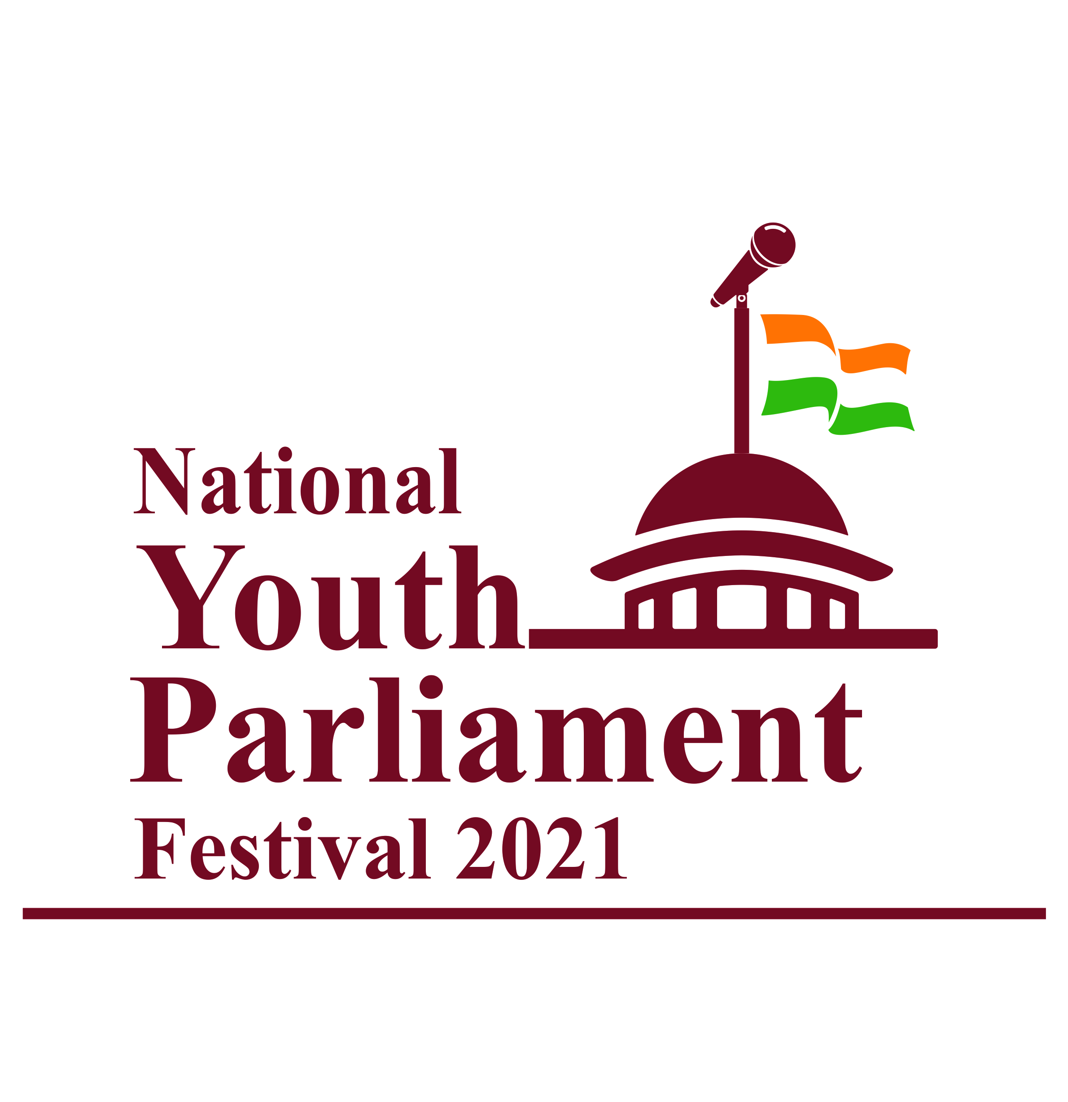
National Youth Parliament Festival 2021: Be The Voice of New India
Find Solutions and Contribute to Policy
Guidelines for Participation
I. Background
The Honourable Prime Minister shared the idea of youth becoming the voice of India in his Mann ki Baat address of 31stDecember, 2017:
“I got an idea whether we could organize a mock parliament in every district of India? Where the youth between 18 and 25 could sit together and brain storm about new India, find ways and chalk our plans. How could we realize our resolves before 2022? How could we build an India of the dreams of our freedom fighters?”
He categorically spoke about giving a chance to the youth to put forth their views on various issues concerning the country.
“I propose that a mock Parliament be organized… comprising one young person selected from each district who would participate and deliberate on how a new India could be formed in the next five years. How can resolve be transformed into reality?”
He reiterated his desire to organize the District Youth Parliaments in his address at time of the inaugural of the 22nd National Youth Festival on 12th January 2018.
Thereafter the First National Youth Parliament Festival was organized in January-February, 2019 wherein 56 finalists ( 32 Female and 24 Male) and 700 delegates representing each district participated at National Youth Parliament. Hon’ble Prime Minister addressed the youth and also gave away the Prizes to the National Awardees.

II. OBJECTIVES OF ORGANISING THE NATIONAL YOUTH PARLIAMENT FESTIVAL
- To hear the voice of youth between 18 and less than 25 years of age, who are allowed to vote but cannot stand as a candidate for election, through deliberations in Youth Parliaments at district level and above.
- To encourage the youth to engage with public issues, understand the common man's point of view, form their opinions and express it in an articulate manner
- To develop and enhance decision making abilities
- To develop in them a respect and tolerance for the views of others.
- To develop in them an understanding that respect for rules is essential for conducting any discussion systematically and effectively.
- To obtain and document their opinions on Vision of New India in 2022.
- To make available their views to policy makers and implementers to take it forward.
III: CRITERIA FOR PARTICIPATION
- Youth, to participate in Youth Parliament must be above 18 and less than 25 years of age as on 30thNovember, 2020. The onus will be on the participant to furnish correct information in this regard. Furnishing of false information will lead to disqualification from participation in the Parliament at whatever stage.
- The individual need not necessarily be a student of an educational institution to participate in the Youth Parliaments.
IV: FORMAT
- Youth Parliaments will be conducted at three levels:
- District Youth Parliament (DYP) will be conducted on virtual mode at the district level. Preliminary rounds of screening will be conducted to select youth for participation in the DYP.
- State Youth Parliament (SYP) will be conducted on virtual mode. The youth selected by a Jury from the District Youth Parliament will participate at the State level in SYP.
- National Youth Parliament (NYP): The youth selected by a Jury from the State Youth Parliament will participate at the National level in NYP in New Delhi .

- The themes and subjects will be provided to the participants to conduct and facilitate participation at each of the above levels.
V: TIMELINE
- District Youth Parliament (DYP) to be organized in 150 specified districts: 24-29 December,2020 ( List enclose at Annexure –I)
- State Youth Parliament (SYP): 01-05 January,2021
- National Youth Parliament (NYP): 12-13 January,2021
VI: SELECTION PROCESS
A: Selection at District Level
Conduct of District Youth Parliament (DYP): 24th to 29th December,2021
District Youth Parliaments will be organized at 150 specified districts. Each event will be for a cluster of 4-5 districts so that these 150 DYPs will cover most of the districts of the country. The District Youth Parliament (DYP) will be organized virtually by taking the youth selected from individual districts.
The two (2) winners from each District Youth Parliament (DYP) will participate at the State level. A certificate of merit will be awarded to the best speakers from the DYP in the panel. Every participant will be given a certificate of participation (format enclosed).
The evaluation criteria to select speakers for State Youth Parliament by the Jury will be as given below:

- Articulation
- Clarity of Thought
- Content knowledge
- Demeanor
Each evaluation criteria will carry 25 points. Final evaluation will be made out of100 points.

B:Selection at State Level
Conduct of State Youth Parliament (SYP): 01-05,January,2021
29 State Youth Parliaments will be organized on virtual mode to cover all States and Union Territories. Winners from each DYP will join together in State Youth Parliament (SYP) and deliberate on given topics in the presence of a Jury on virtual mode.
The evaluation criteria to select speakers from SYP for participation in the National Youth Parliament (NYP) will be as under:

- Articulation
- Clarity of Thought
- Content knowledge
- Demeanour
Each evaluation criteria to carry 25 points. Final evaluation will be made out of 100 points. The concerned Jury will prepare a panel of three (3) best speakers from each State Youth Parliament (SYP) out of which the First position holder from each state would participate as speaker in the National Youth Parliament festival. The 2nd and 3rd position holder from each state will come to Delhi and will be a part of National Youth Parliament. A certificate of merit will be awarded to the best speakers from the State in the panel. Every participant will be given a certificate of participation.

Selection at National Level

Conduct of National Youth Parliament (NYP)

The final stage of the National Youth Parliament (NYP) will be held at New Delhi. 87 State winners ( 1st , 2nd and 3rd prize winners will participate in the National Youth Parliament of which 29 will be speaking on selected topics. Remaining 58 will be just attending the National Youth Parliament. The evaluation criteria to select the winners of the National Youth Parliament (NYP) by concerned Jury will be as under:
- Articulation
- Clarity of Thought
- Content knowledge
- Demeanour
Each evaluation criteria to carry 25 points. Final evaluation will be made out of 100 points. The three best speakers at the national level will be awarded Rs 2 lakhs, Rs 1.50 lakhs and Rs 1 lakh respectively alongwith a certificate of merit. Every participant will be given a certificate of participation (format will be provided by Ministry).
VII: LANGUAGE
To ensure that all sections of youth population are able to participate, the language for participation at District and State Parliaments will be Hindi, English or Official Language of the State. However, participants will be able to use either Hindi or English for National Youth Parliament.

VIII: JURY

Jury will be set up at all three levels i. e. District, State and National levels. The Youth Parliaments i.e. DYP, SYP & NYP will each be adjudged by a five (5) member Jury. Each Jury will be comprised of the following members:
  - Member of Parliament /Member of Legislative Assembly/Eminent politicians
  - Retired/serving government officials
  - Eminent Artist
  - Eminent journalist/writers
  - Academicians of repute
At District and State levels, relevant local eminent personalities will be included to form the Jury. At the National level, nationally eminent personalities will be included in the Jury.
IX: TOPICS FOR DISCUSSION
The topics for discussion at different levels will be released as per following details:
- Topics for DYP: 22nd December,2020
- Topics for SYP: 31stDecember,2020
- Topics for NYP: 10th January,2020
The list of topics for each of the above levels will be hosted on www.yas.nic.in, www.nss.gov.in; and www.nyks.nic.in
Four ( 4) minutes time will be given to each participate to speak on the given topic at the District and State level Youth Parliaments. The list of the topics is attached at Annexure II.

X: REGISTRATION AND TREATMENT OF DATA
All willing participants will have to register for District Youth Parliaments which would be initiated by NYKS and NSS for District Youth Parliament and representation of women, tribal youth and others from minor sections will be ensured. The data documented in the process will be the property of Ministry of Youth Affairs and Sports.
XI: LOGISTICS
For District Youth Parliament (DYP)&(SYP), the participants will not be provided any travel cost or any other logistical support as these will be organized on virtual mode.
For National Youth Parliament (NYP), the participants will be provided boarding & lodging facility and the travelling expenses (By Economy Class Air). The participants will have to travel by Air India and only can travel by private airlines where no Air India services are available.
XII : COVID -19 NEGATIVE REPORT
The participants at the National Level have to come with the RT PCR Negative test Report from their respective states upto maximum 96 hours before commencement of the programme failing which they will not be allowed to participate..

